Access from New Chitose Airport to Sapporo Convention Center

JR Namboku subway Tozai subway
Rapid Train JR line Odori line Higashi Sapporo
New Chitose Airport Sapporo Station Station
1,040 JPY, 36 min Station 200 JPY, 2 min 240 JPY, 5 min
240 JPY, if only transfer at Odori Station
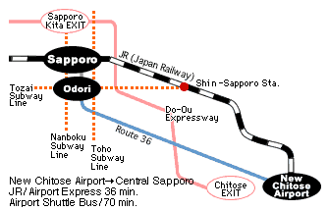
The railway tickets are available at ticket-vending machine near ticket gates. For Rapid Train, named as "Airport," no extra-charge is required.

New Chitose Airport to JR Sapporo Station
To get on JR Rapid Airport Train at New Chitose Airport
Map http://www.new-chitose-airport.jp/en/access/jr/images/flow_pdf_jr.en.pdf
Time Table http://www.new-chitose-airport.jp/en/access/jr/timejr/

Departure time of New Chitose Airport
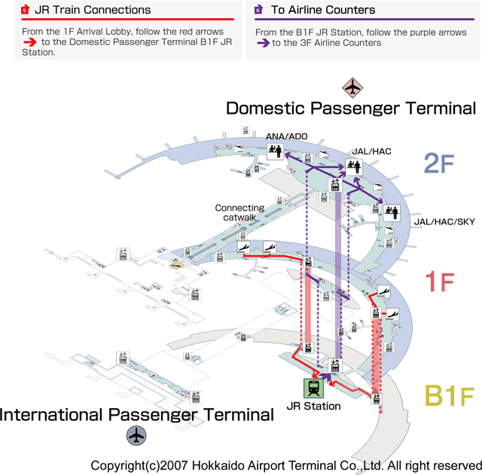
8h 17, 34, 49 min
9h ~ 20h 04, 19, 34, 49 min
21h 04, 16, 30, 50 min
22h 00, 14, 50 min
(36 min to Sapporo)

Sapporo Subways
See Figure in the next page.

JR Sapporo Station or Odori Station to Higashi Sapporo Station

The subway station, "Higashi Sapporo Station," is the nearest one to Sapporo Convention Center.
There are several Sapporo subway lines. If you stay around JR Sapporo Station, you will take two subway lines from your hotel to Sapporo Convention Center.
First, you should go the subway station of Sapporo (N06). Please note that the JR Sapporo Station itself is different location from the subway station of Sapporo. It takes about 4 minutes from JR Sapporo Station to the subway station of Sapporo.
Next, you take the subway and then go to Odori Subway Station (N07). It is the next subway station of Sapporo Sta. You should take another subway line. The line is "Tozai subway line". Then, you should get off at the station of "Higashi Sapporo Station"(T12), 3rd from "Odori Station (T09)". It takes around 6 min.
If you stay around Odori area, you will take only Tozai subway line to go to Sapporo Convention Center.

JR Sapporo Station Map: http://www2.jrhokkaido.co.jp/global/english/access/sapporo.html

Higashi Sapporo
Higashi Sapporo Station to Sapporo Convention Center
10 min walk from Higashi Sapporo station to Sapporo Convention Center for TOCAT 6 / APCAT 5.

